**600 W. 41st Ave, Suite 202 A**

**370 Sq. Ft.**

**Available Now**

* **$650.00/month ($1.75/SF).**
* **Open Layout.**
* **Large window in the office.**
* **Heating and air conditioning.**
* **Sprinkler protected.**
* **May have an opportunity to be leased with a detached 272 SF warehouse in the same building.**

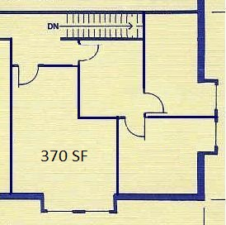

**Arctic Business Park I**

**Office space for lease**

Office **FOR LEASE** inMidtown

**Available Now**

**For Additional Information Contact:**

**Chad R. Powelson Robert Moats**

**Phone: 907.562.2244 Phone: 907.562.2244**

**Cell: 907.230.1706 Cell: 907.632.9092**

**Email: ChadP@LeaseAlaska.com Email: RobertM@LeaseAlaska.com**

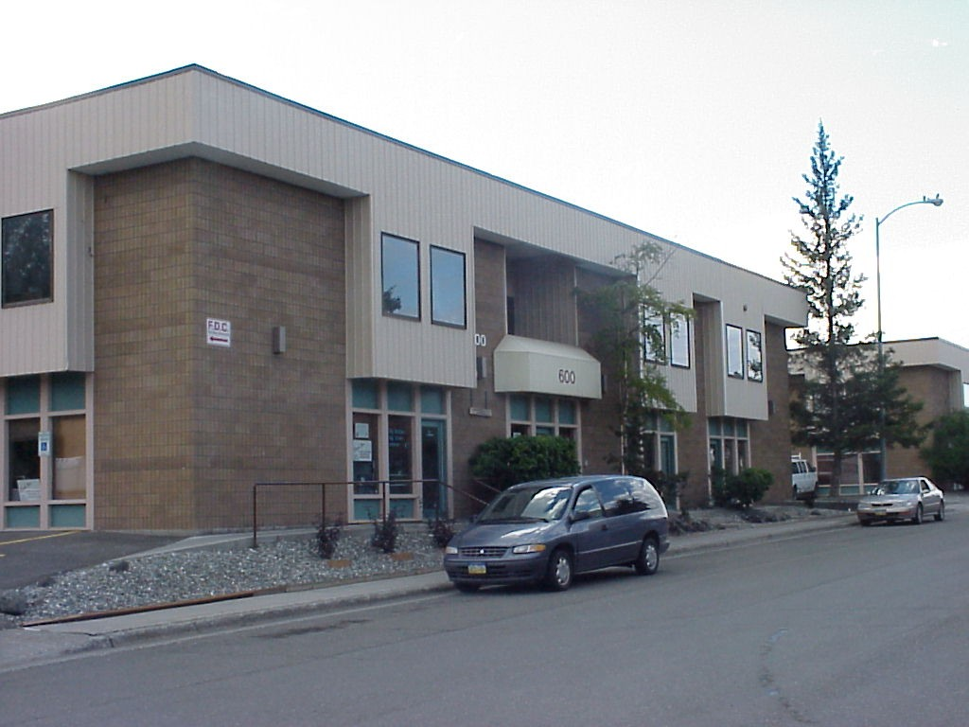



**Western Enterprises, Inc.**

Commercial Real Estate Services

*Giving Alaskan Businesses A Place To Grow Since 1972*

4101 Arctic Blvd, Suite 203 Anchorage, Alaska 99503

www.LeaseAlaska.com