“Midtown” Warehouse Lease | - Unit A  - •  - 4101 Arctic Blvd.
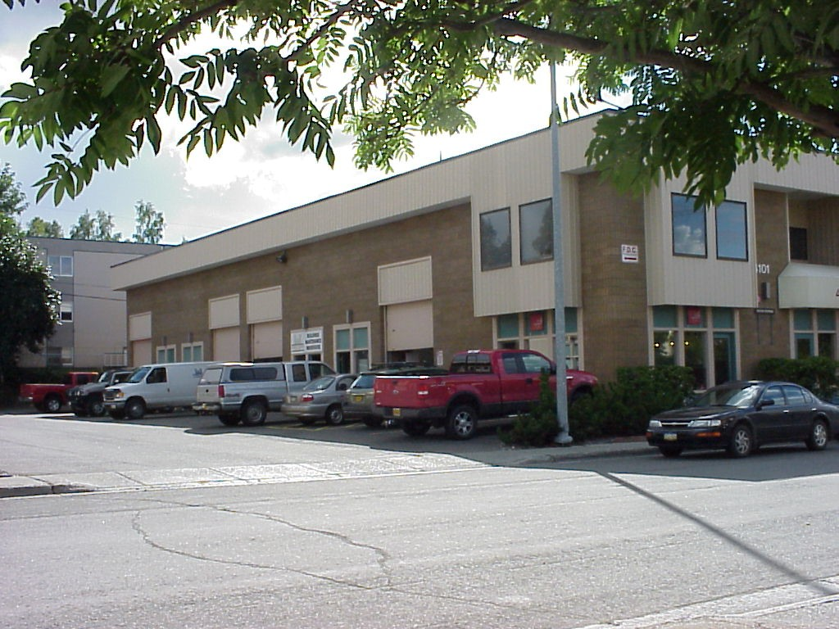MLS listing # 20-409  Description of Unit/Suite (1,218 SF)  Excellent high storage warehouse space with a bonus mezzanine deck and various rooms/areas created within (not shown in layout pic). The Unit also features a storefront man door access, a 10' x 12' overhead door, a floor drain, access to common area restroom facilities, and is sprinkler protected.  Terms  Minimum lease term is 24-36 months. Tenant pays prorated increases of Tax and Insurance over the base figure, and also takes Gas and Electric meters out in their own name. $1,585.00/month ($1.30/SF). | 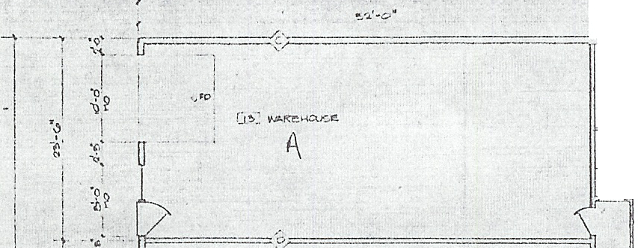  Contacts  Robert A. Moats - Assoc. Broker  907-632-9092  RobertM@LeaseAlaska.com  Chad R. Powelson - Broker  907-230-1706  ChadP@LeaseAlaska.com  Office # 907.562.2244

