Combination office / WHse for Lease | - Unit G&H  - •  - 520 W. 58th Avenue
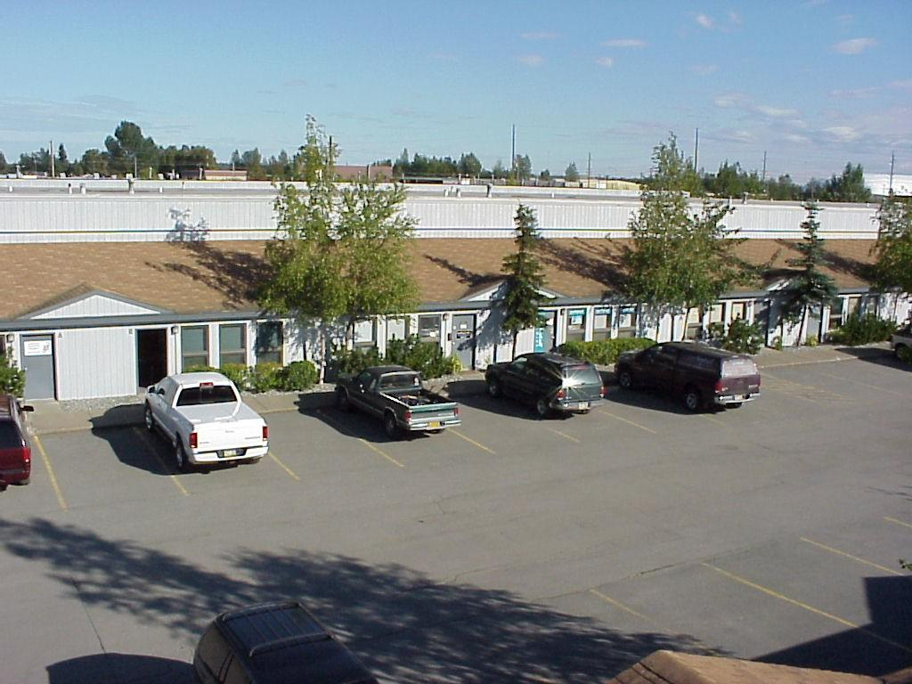  MLS listing # 19-16803  Description of Unit/Suite (2,400 SF)  This is a unique deviation of the standard Arctic Center combo space layout, as these two neighboring Units never had a demising wall built into the back part between the warehouses. The result is an open warehouse area that is roughly 48' x 46' and then two separate front offices that are roughly 14' by 24' each. The offices will have newer carpet and fresh paint, and they also feature vaulted ceilings and large windows. The warehouse portion of the spaces features high ceilings, the restrooms (2), floor drains (2), 10' x 12' overhead doors (2), and multiple 3'-0'' man door accesses. The space is sprinkler protected. No Auto.  Terms  Minimum lease term is 24-36 months, and tenant pays prorated increase of Tax, Insurance and all G & E which they take out in their own name. List Price is $3,240.00/month ($1.35/SF) | 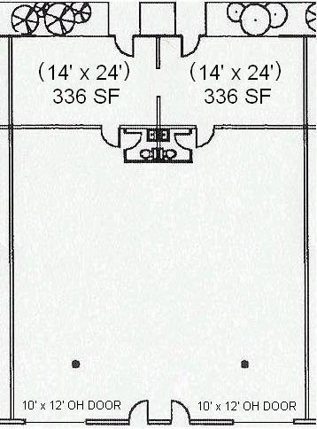  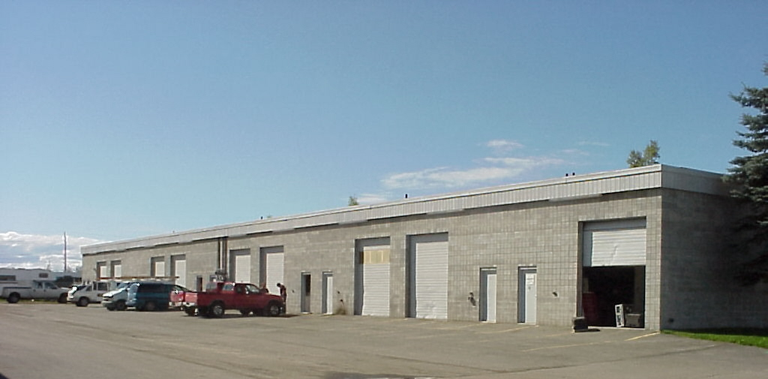  Contacts  Robert A. Moats - Assoc. Broker  907-632-9092  RobertM@LeaseAlaska.com  Chad R. Powelson - Broker  907-230-1706  ChadP@LeaseAlaska.com  Office # 907.562.2244

